These photos were taken on April 30, 2019. This is the first filling I noticed in the area. There are large, linear tension cracks (red dashed lines) parallel to the slope face indicating that at least the filled material is failing and beginning to move downslope. Note the rear corner of the home (389 Riverside Ave) in top photo.
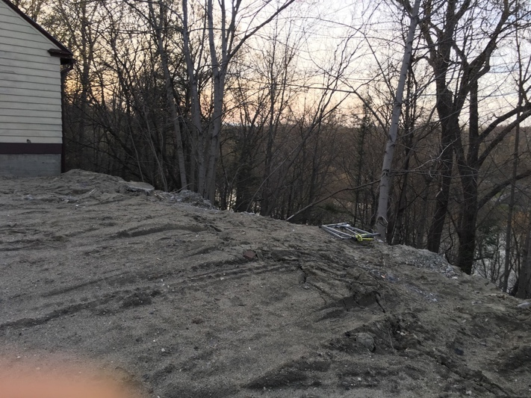
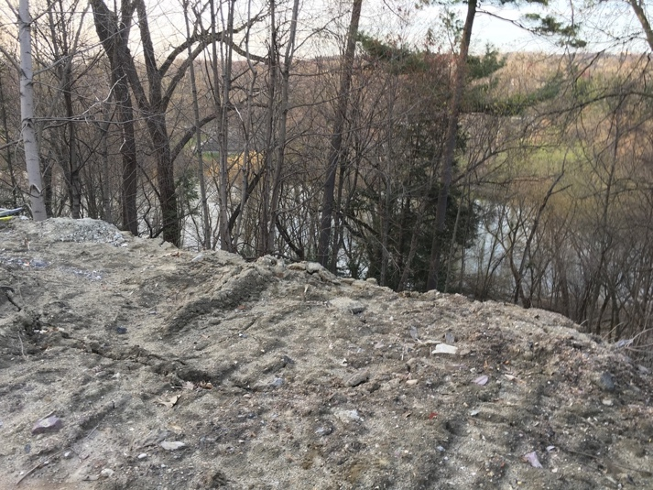
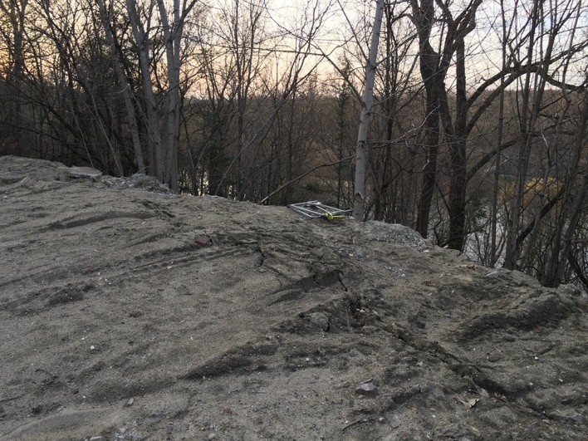

By May 24th, 2019 rate of downslope displacement has increased. Slump blocks are creeping downslope under automobiles parked near the edge of the slope. Additional dumping of waste and fill behind 389 Riverside Ave.
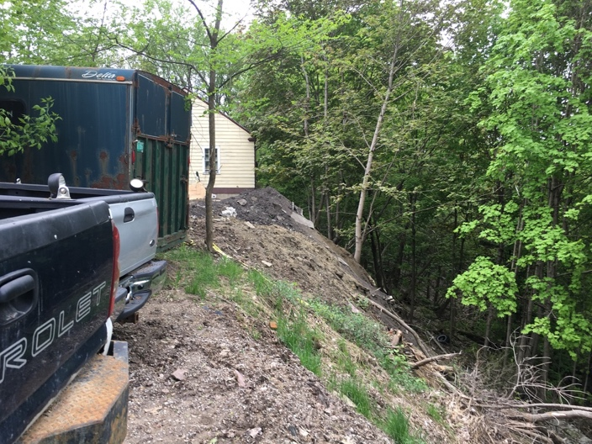
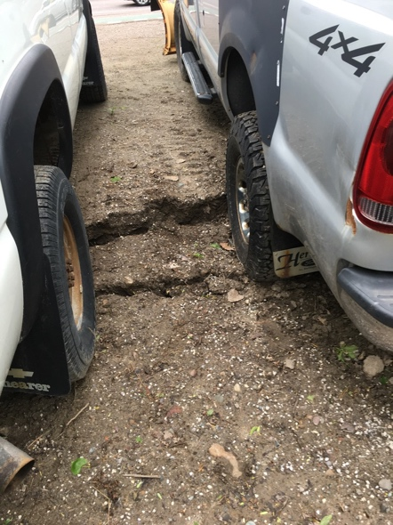
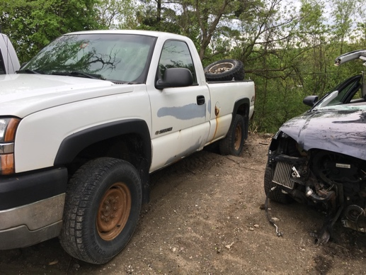

Photos taken on June 20, 2019 shows still increasing downslope movement of fill with tilting of trees and additional dumping of stone and cement near 389 Riverside Avenue. There are large, open ground cracks.
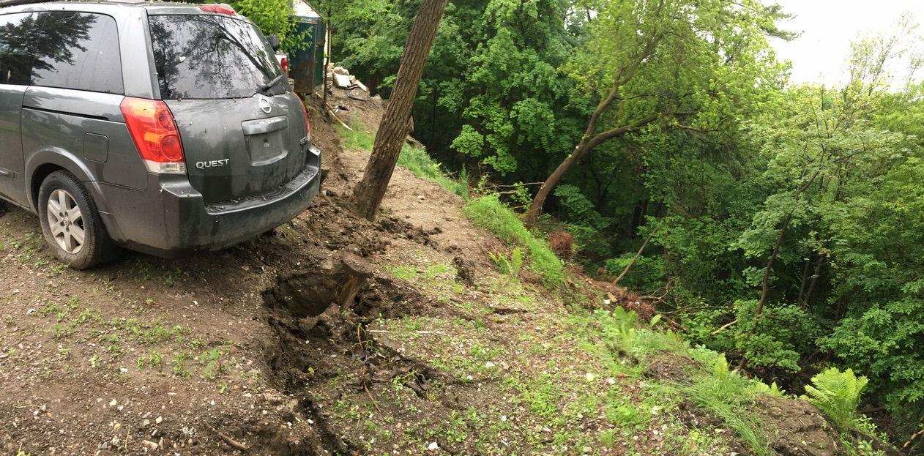

July 1, 2019. Ground cracks deepen as slide blocks move further downslope. Tilting of trees increases.
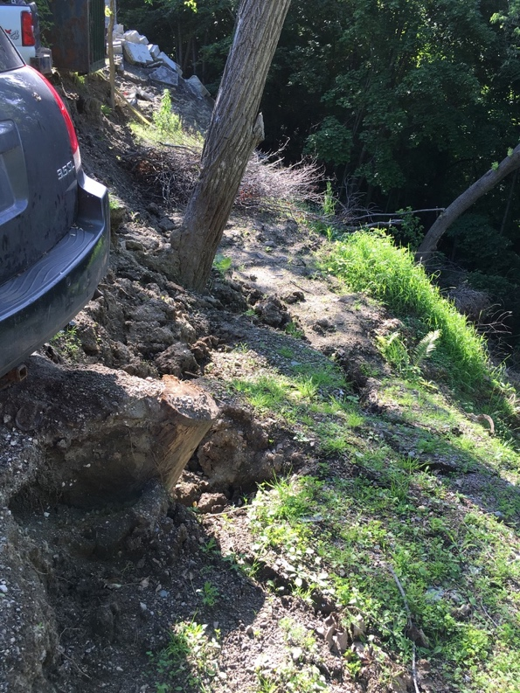
August 27, 2019. Extensive filling with debris after slides in July. Material moved downslope in July and was pushed over the slope during filling operations in August.
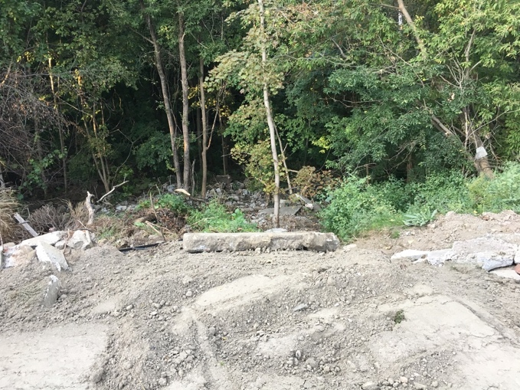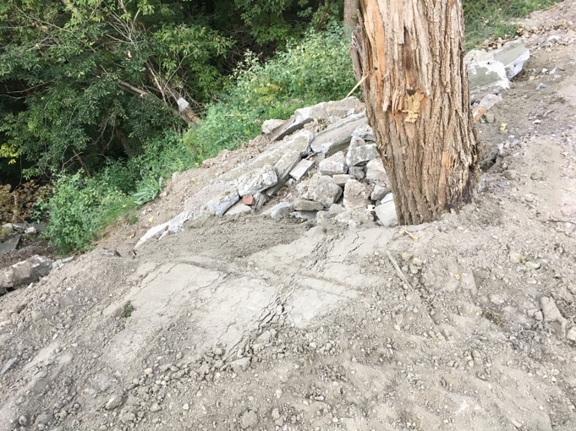
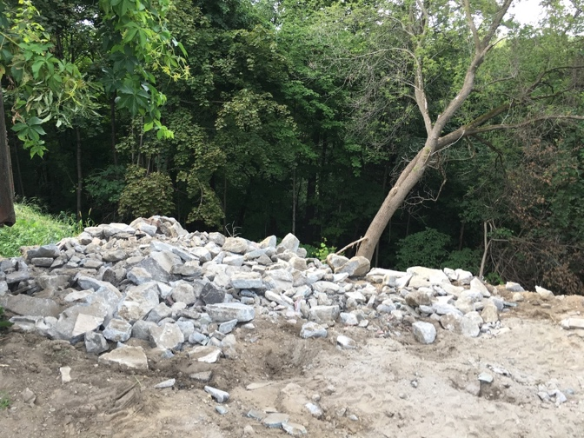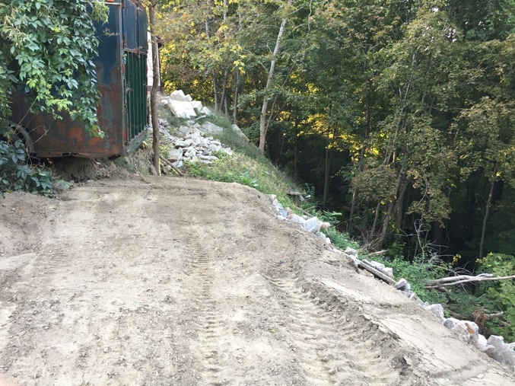
September 20, 2019. I began to notice dumping of organic debris behind the auto body shop followed by cutting of trees.
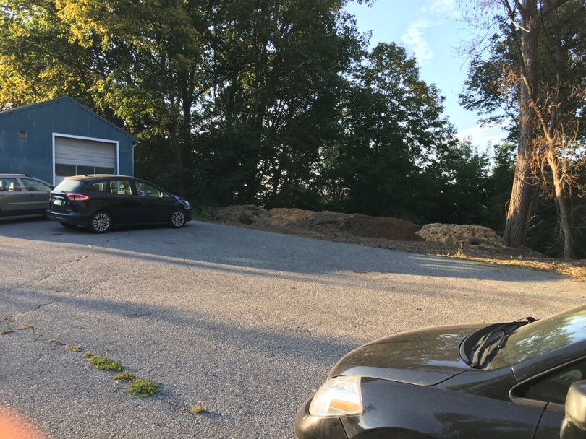
October 11, 2019. Ground cracks reforming in fill material between Hitch shop and 389 Riverside Avenue.
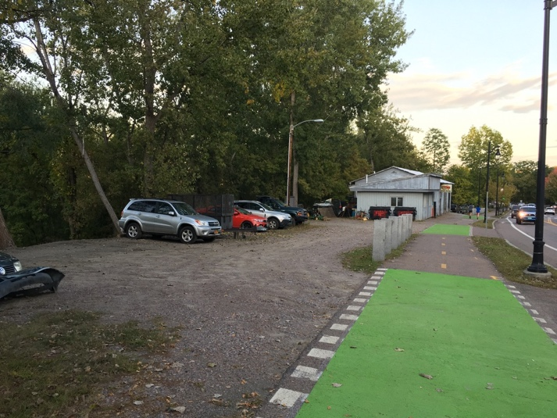
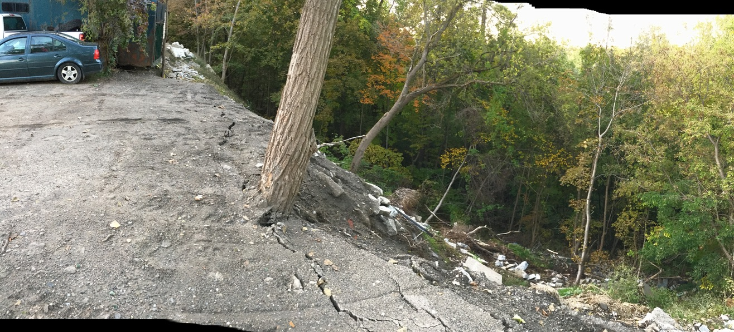

November 1, 2019. Following 3 inches of rain on October 31, 2019 (no failure at 1530), I noted almost complete failure of the fill material along with native material had occurred by 1525 on November 1, 2019. In addition to the landslide material, which as of the afternoon of November 1 went all the way down the slope and had reached the waters of the Winooski River (it was in flood), another series of ground cracks had developed. The location of these cracks implies that the failures are stepping farther back than previously and are likely in native material, not just fill. The cracks are elongate and project toward the house at 389 Riverside Avenue. Additional cracks have formed in the organic fill dumped near the body shop.
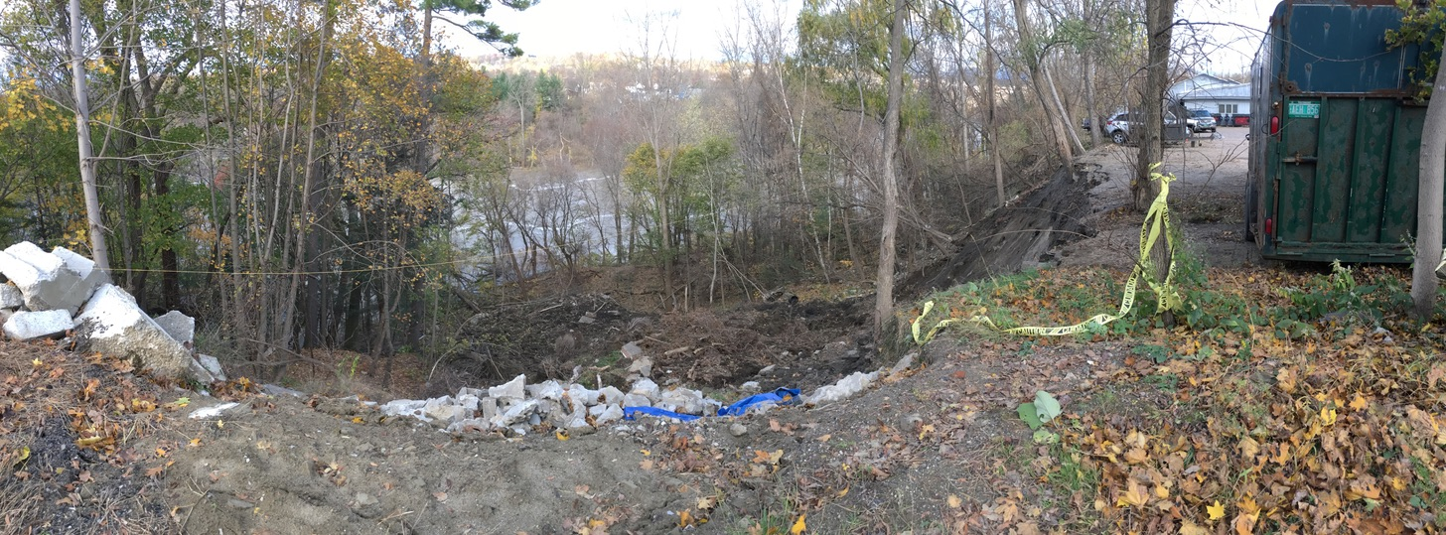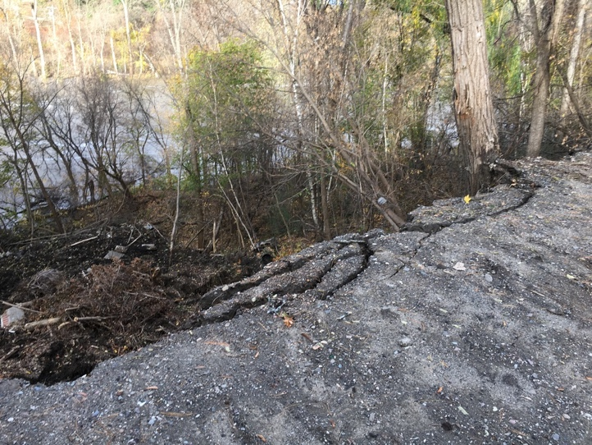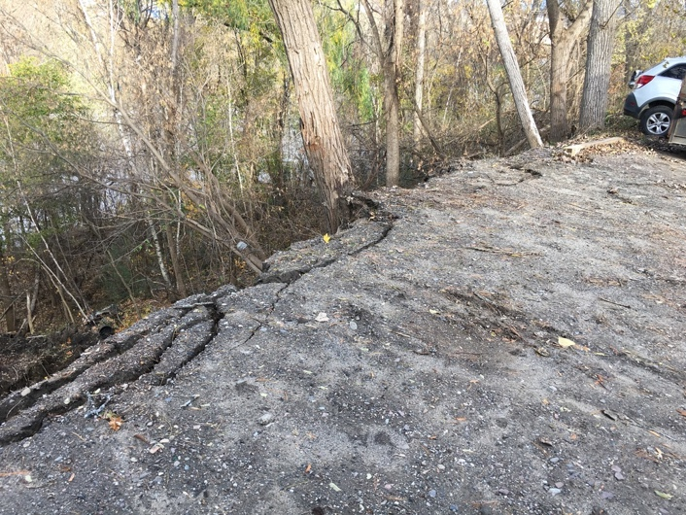
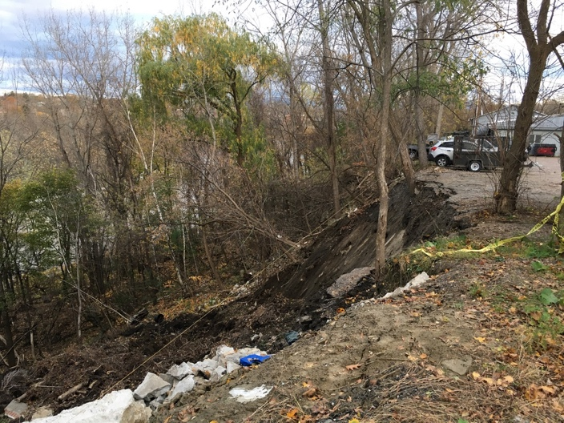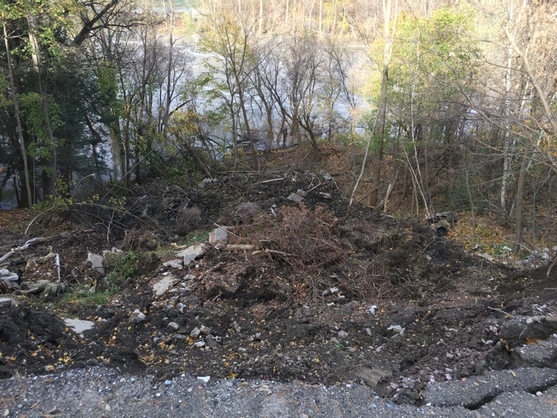
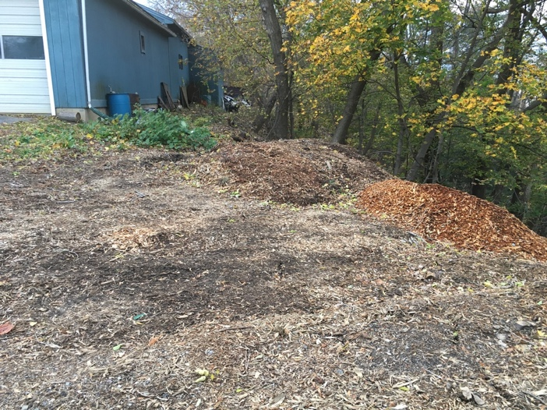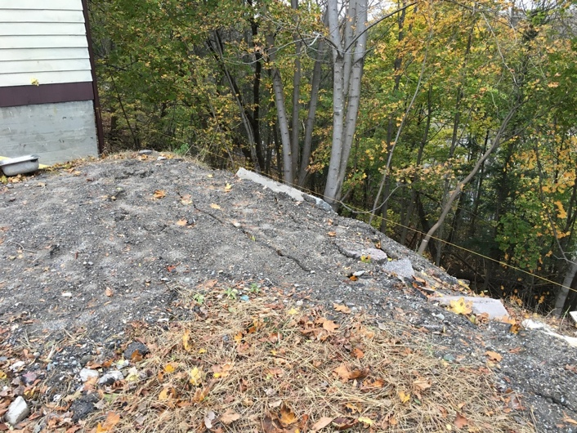

November 2, 2019. With flow on the Winooski River dropping, I attempted to walk the Burlington Wildways trail from Intervale Road to the base of the slide. Access was possible from downstream (Intervale Road) on the Burlington Wildways trail. The trail was wet and muddy but passable. The high water line from the flood is clearly visible along the length of the trail.
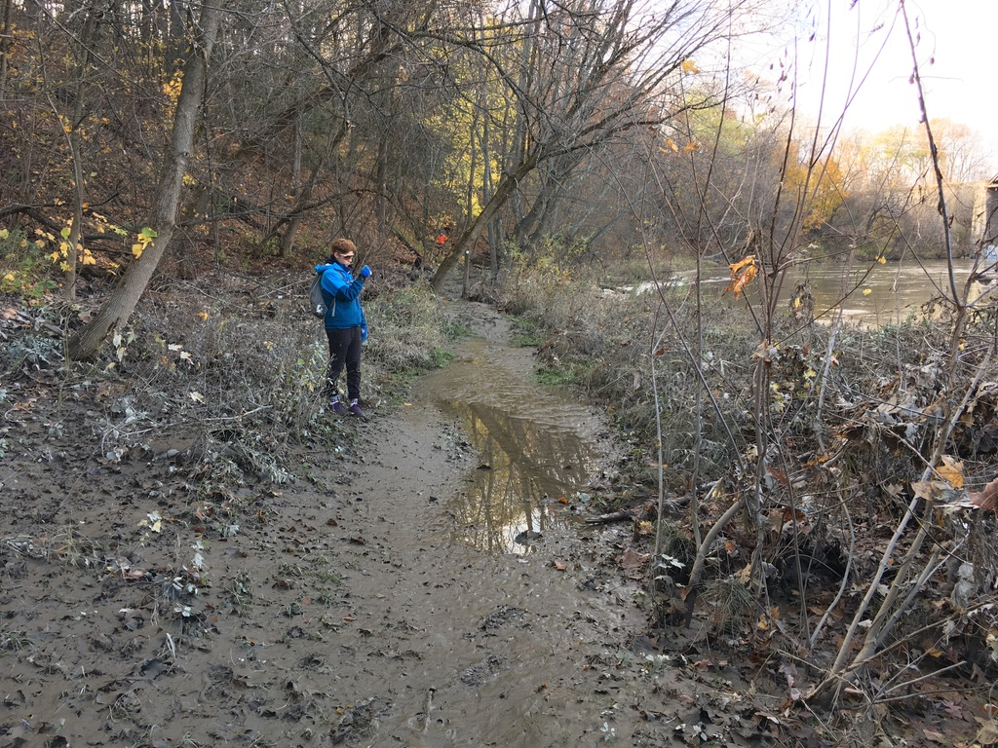
I reached the runout area of the slide (documented in the photographs on preceding pages). The newly emplaced material is clearly delineated by color and debris content (waste concrete and stone); it went far enough downslope to interact with Winooski River flood waters. I am standing in the overbank deposits of silt and sand, laid down during the flood. The landslide material is in front of me and to the right.
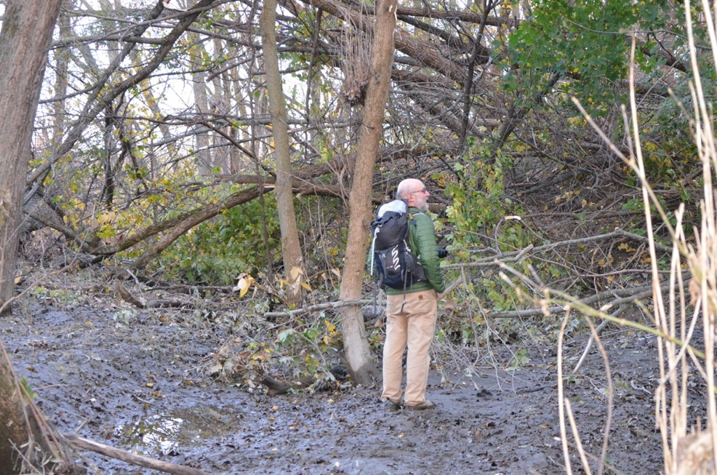

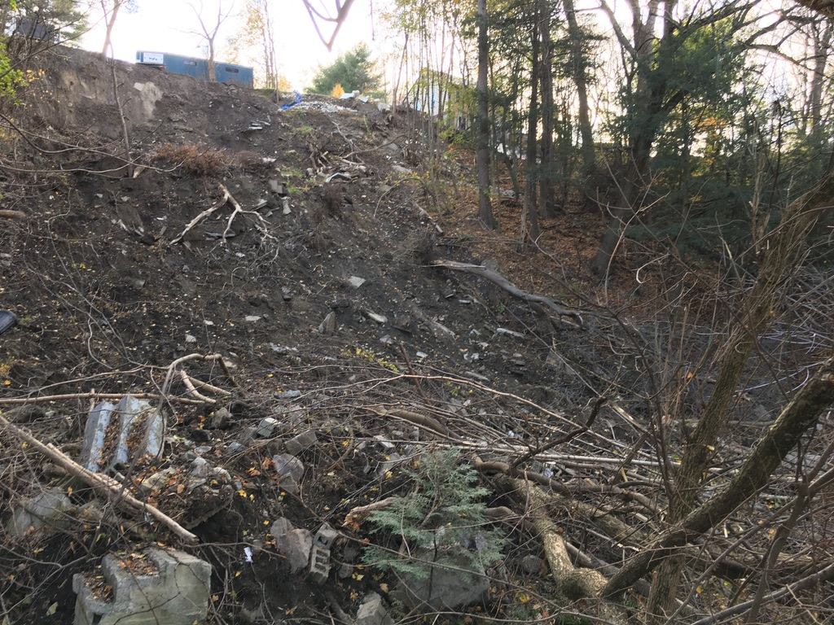
Much of the debris appears to be fill and not native material (note the cinder blocks and intact concrete stairs on the lower left, this is the toe of the slide and these were the waste materials emplaced over the summer by dumping over the edge of the parking lot). There are large blocks of concrete and stone throughout. There is wood from trees and shrubs. Some of the matrix material appears to have liquified during the slide; the runout zone was soft and hummocky and difficult to traverse.
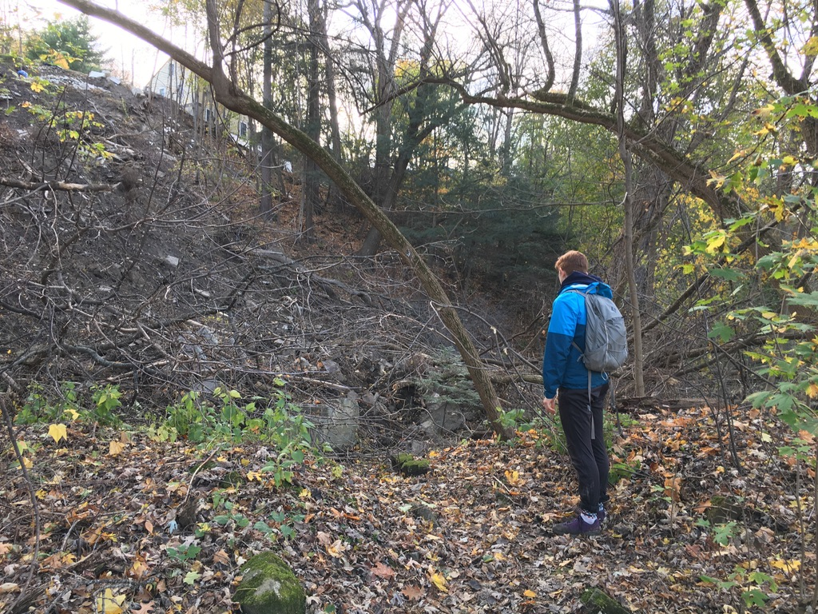
Debris from the slide has completely buried the Wildway trail where it runs between Intervale Avenue and Salmon Hole. The debris is several to many feet thick over what I estimate roughly to be 50 to 80 feet of the trail. The person in the photo above is standing on the trail just before it is buried by the slide material.
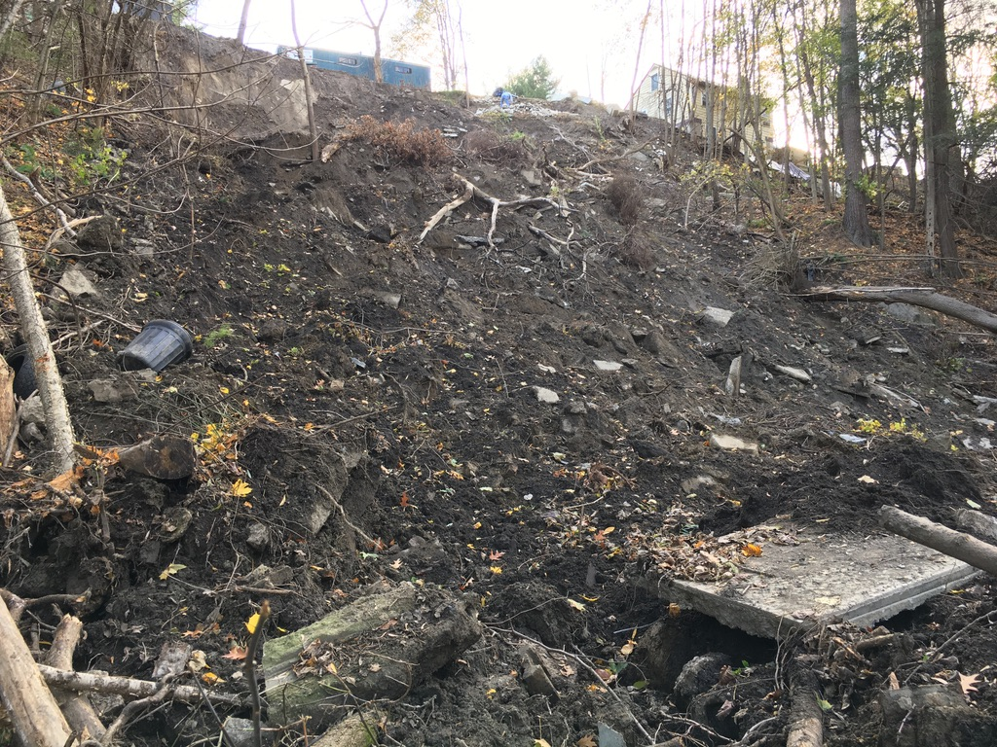
From the run out zone of the slide, it appears that most of the fill emplaced at the top of the hill during the spring and summer of 2019 has failed and is now at the base of the slope. The remaining fill material does not appear stable and is located on several down dropped blocks that have moved partially downslope. These could reactivate and move downslope at any time although they are more likely to move during and after periods of rainfall.
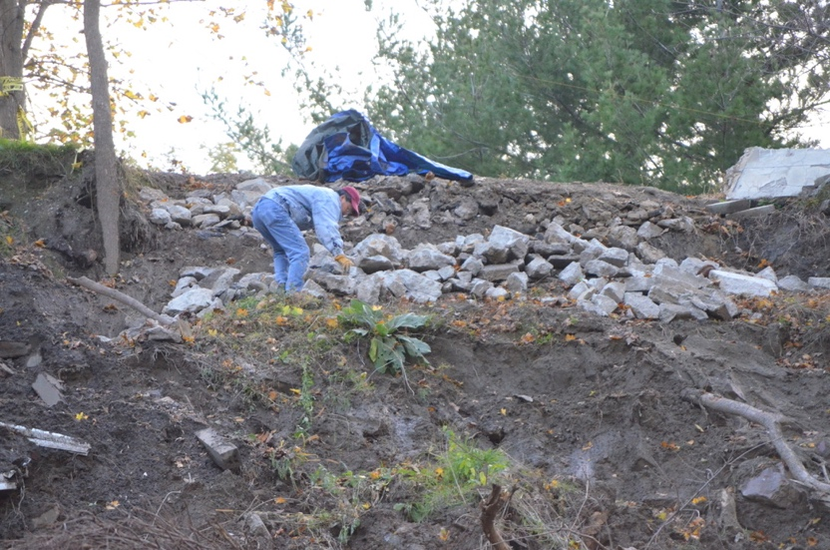
While I was there, a man, shown in the photos, was moving rocks off the active slide face. The photo above shows him perched on a slide block which had dropped several feet. It would seem prudent to fence off the top of the slide to prevent this sort of access. The block on which he is perched could fail any time.

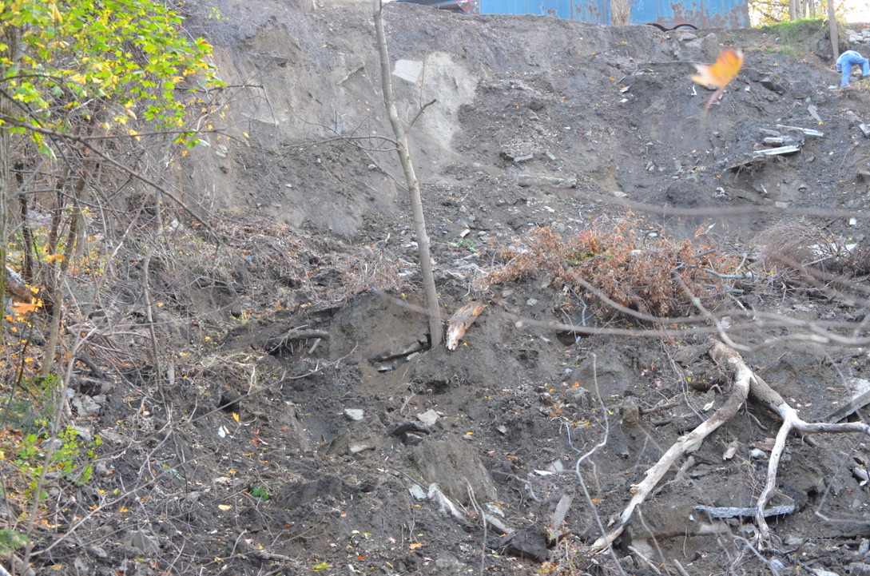
The scarp above the run out zone is vertical and near vertical. The vertical scarp reveals a diamict (poorly sorted material with what from a distance appear to be large slabs of rock or concrete). I did not see any native material (bedded sand and silt). Rather, from the appearance of the scarp, it seems possible, even likely, that the slide has worked back into fill, perhaps emplaced after the very large 1955 slide that took out Riverside Avenue. Air photograph analysis, which I hope to do with student(s) in the next several weeks, should complement existing historic photographs and allow better definition (which would need to be confirmed by drilling and/or geophysics) of the margins of the 1955 slide complex and the nature of the fill used to fill the slide scar.

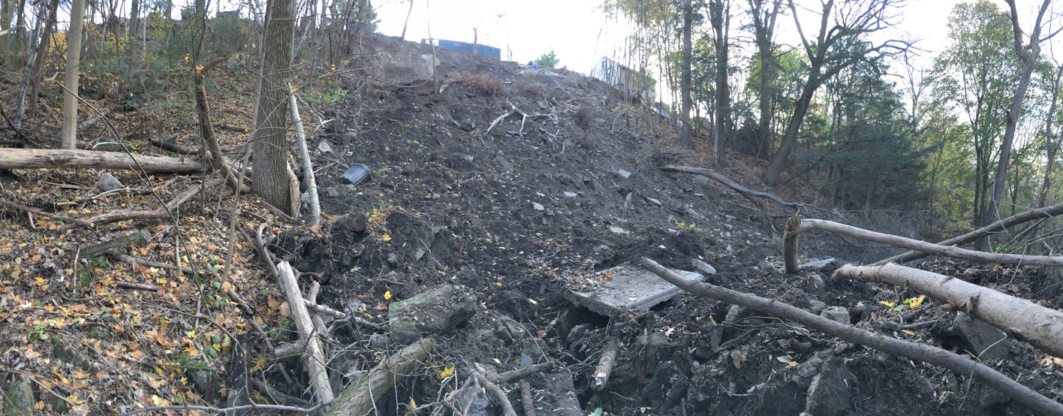
Above is a panorama of the slide scar and runout zone from below showing the intact trees that came down the slope with the fill that had been emplaced over the summer.

This area is capable of generating very large landslides, capable of removing Riverside Avenue. The largest historic slide appears to have occurred in 1955. There are numerous images in the UVM Landscape Change Program archive. I’ve added one example below. Here are the URL’s for some of the many others. Note the large slabs of pavement in the foreground of the lower image. These look similar to those cropping out in the head scape of the November 2019 slide.
http://www.uvm.edu/landscape/search/details.php?ls=01784
http://www.uvm.edu/landscape/search/details.php?ls=01783
http://www.uvm.edu/landscape/search/details.php?ls=01786
http://www.uvm.edu/landscape/search/details.php?ls=01781
